Character

Definition:
# Source: AI Source: Provided by: [Data Path: Persons Table -> ID Column: 1, Name_En Column: Motasem Essam] -> From: [Chatgpt (GPT‑5 Mini)] on [1/26/2026]
A character is the smallest unit of data that represents a single symbol. It can be:
- A letter (A, b)
- A digit (0, 9)
- A special symbol (@, #, !)
- A space or control character (like newline \n)
Characters are often used as building blocks for strings in programming.

Key Points
# Source: AI Source: Provided by: [Data Path: Persons Table -> ID Column: 1, Name_En Column: Motasem Essam] -> From: [Chatgpt (GPT‑5 Mini)] on [1/26/2026]
- Characters are usually stored using ASCII or Unicode codes in memory.
- In most programming languages, a character is enclosed in single quotes: 'A', '9', '@'.
- A string is simply a sequence of characters.

Examples
# Source: AI Source: Provided by: [Data Path: Persons Table -> ID Column: 1, Name_En Column: Motasem Essam] -> From: [Chatgpt (GPT‑5 Mini)] on [1/26/2026]
1. Python
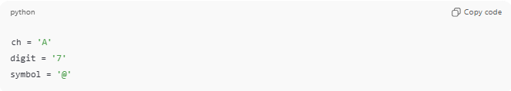
ch = 'A'
digit = '7'
symbol = '@'
2. C
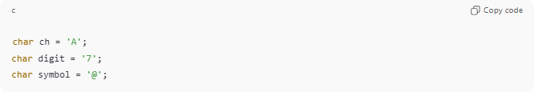
char ch = 'A';
char digit = '7';
char symbol = '@';
3. Java
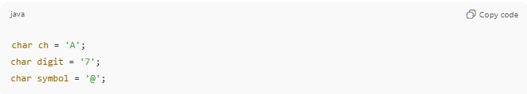
char ch = 'A';
char digit = '7';
char symbol = '@';

Operations on Characters
# Source: AI Source: Provided by: [Data Path: Persons Table -> ID Column: 1, Name_En Column: Motasem Essam] -> From: [Chatgpt (GPT‑5 Mini)] on [1/26/2026]
- Can be compared: 'A' > 'B'
- Can be converted to numbers using ASCII: ord('A') → 65
- Can be converted back from numbers: chr(65) → 'A'

Analogy
# Source: AI Source: Provided by: [Data Path: Persons Table -> ID Column: 1, Name_En Column: Motasem Essam] -> From: [Chatgpt (GPT‑5 Mini)] on [1/26/2026]
- Character → A single bead
- String → A necklace made by stringing beads together

✅ Summary
# Source: AI Source: Provided by: [Data Path: Persons Table -> ID Column: 1, Name_En Column: Motasem Essam] -> From: [Chatgpt (GPT‑5 Mini)] on [1/26/2026]
- Character = smallest unit of data representing one symbol.
- Characters combine to form strings.
- Stored using ASCII or Unicode.

